April 7, 20XX

Mike Smith, President
AnyTown School District Board of Directors
C/o Joan Barkley, Board Secretary
AnyTown School District
Email jbarkley@AnyTown.k12.AnyState.us
AnyTown, AnyState

Dear President Smith,

This is to advise you of our group’s intentions to begin video recording future school board meetings of the AnyTown School District. We do this under the general authority provided to “the public” to attend such meetings, found in I.C.L. § 1-25-XX.

We will record on a per meeting basis and will govern our activities under the following guidelines.

- We will conduct ourselves in an orderly and appropriate manner.
- The camera and operator will leave the board room whenever the board takes a vote to lawfully enter into a “closed meeting”.
- When not on the agenda, we understand we have no privilege to speak in the board room at any time.
- We take all reasonable steps to insure the camera is not set up in such a fashion to obstruct the proper flow of any pedestrian traffic, while yet establishing the best recording “angle” possible.

The Attorney General’s office has an advisory (citing state code) posted on their website outlining the public’s right to video record during public meetings. If you need a refresher I’d encourage you to see their site here: www.YourStateAttorneyGeneral.gov/video recording

Our attorney is John Q. Smith. If the district’s legal counsel would like to discuss our activities with him further, please advise him to contact Mr. Smith at Ph XXX-XXX-XXXX or Email at JohnQSmith@SmartestLawyerInTheCounty.com

Sincerely,
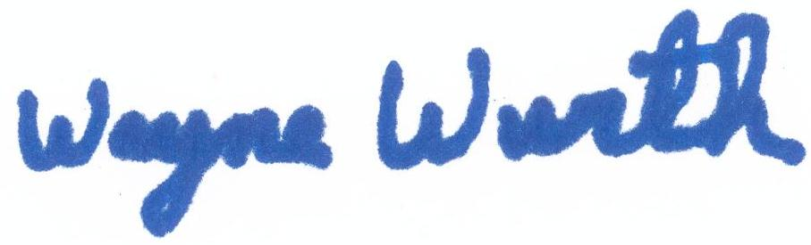
Wayne Wurth
Ph XXX-XXX-XXXX, waynewurth@anyserver.com
Group Name, AnyTown

CC: Dr. Joseph J. Johnson, Superintendent, jjohnson@AnyTown.k12.AnyState.us

